Northwest District

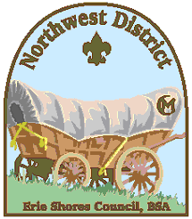

**Award Nomination Form**

**POST ADVISOR OF THE YEAR**

Name of Advisor:__________________________________ Post: _________

Years of Volunteer Service w/BSA_____________

Trainings Completed: ______________________________________________________

Other positions held in BSA________________________________________________

_______________________________________________________________________

Person submitting nomination:(Optional)_________________________________________

Briefly describe what traits this person displayed as Advisor: ___________________

_______________________________________________________________________

_______________________________________________________________________

How did this person uphold the values of Scouting?______________________________

_______________________________________________________________________

_______________________________________________________________________

How did this person display their Leadership? __________________________________

_______________________________________________________________________

_______________________________________________________________________

Other information or volunteer positions: ______________________________________

_______________________________________________________________________

_______________________________________________________________________

***Please submit to Scout Service Center or e-mail to:***

**Northwest District:** [**pat.keenan@scouting.org**](mailto:pat.keenan@scouting.org) **(OR)**

**Northwest District Commissioner:** [**amroz@bex.net**](mailto:amroz@bex.net)